# Lab: Polymorphism

Problems for exercises and homework for the ["Java OOP Basics" course @ SoftUni](https://softuni.bg/courses/java-oop-basics).

You can check your solutions here: <https://judge.softuni.bg/Contests/481/Polymorphism-Lab> .

## Overload Method

Create a class **MathOperation**, which should have method add(). Method add() have to be invoked with **two, three** or **four Integers.**

You should be able to use the class like this:

|  |
| --- |
| Main.java |
| **public static void** main(String[] args) **throws** IOException {  MathOperation math = **new** MathOperation();  System.***out***.println(math.add(2, 2));  System.***out***.println(math.add(3, 3, 3));  System.***out***.println(math.add(4, 4, 4, 4));  } |

### Examples

|  |  |
| --- | --- |
| **Input** | **Output** |
|  | 4  9  16 |

### Solution

Class **MathOperation** should look like this:

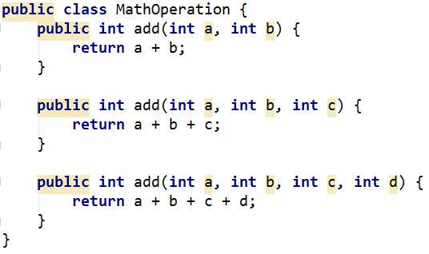

## Method Overriding

Read **n** lines from console. If line consist only **one** **Double** number it is square, if numbers are **two** it is rectangle. Numbers are sides of Rectangle. You need to have two classes:

* **Rectangle**
* **Square**

You should be able to use the class like this:

|  |
| --- |
| Main.java |
| **public static void** main(String[] args) **throws** IOException {  BufferedReader reader = **new** BufferedReader(**new** InputStreamReader(System.***in***));  **int** n = Integer.*parseInt*(reader.readLine());  List<Rectangle> listOfRectangles = **new** ArrayList<>();   **for** (**int** i = 0; i < n; i++) {  String[] reminder = reader.readLine().split( **" "**);  **if** (reminder.**length** == 1) {  listOfRectangles.add(**new** Square(Double.*parseDouble*(reminder[0])));  } **else** {  listOfRectangles.add(**new** Rectangle(Double.*parseDouble*(reminder[0]),  Double.*parseDouble*(reminder[1])));  }  }   **for** (Rectangle rectangle : listOfRectangles) {  System.***out***.println(rectangle.area());  } } |

### Examples

|  |  |
| --- | --- |
| **Input** | **Output** |
| 5  5  25 25  4 5  3 7  2 | 25.0  625.0  20.0  21.0  4.0 |

### Solution

Square class should look like this:

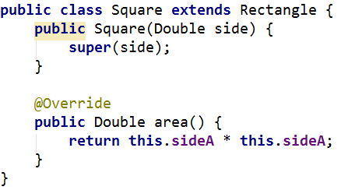

## Shapes

Create class hierarchy, starting with abstract class **Shape**:

* **Fields:**
  + **perimeter**
  + **area**
* **Encapsulation for this fields**
* **Abstract methods:**
  + calculatePerimeter()
  + calculateArea()

Extend Shape class with two children:

* **Rectangle**
* **Circle**

Each of them need to have:

* **Fields:** 
  + **height and width for Rectangle**
  + **radius for Circle**
* **Encapsulation for this fields**
* **Public constructor**
* **Concrete methods for calculations (perimeter and area)**